**What is an IoT platform?**

An IoT platform is an application or service that provides built-in tools and capabilities to connect every “thing” in an IoT ecosystem. By providing functions including device lifecycle management, device communication, data analytics, integration, and application enablement.

An IoT platform harmonizes the many moving parts that contribute to your IoT system. An IoT platform is the foundation for building IoT solutions that deliver value to your business, your customers, your customers’ end users, and your partners. By enabling you to maintain visibility, security, and control over connected assets, IoT platforms enable you to start and scale IoT projects efficiently so you can launch customer-centric services and remain competitive in an evolving market environment.

**Why use an IoT platform?**

An IoT platform is critical to building an IoT ecosystem, it simplifies IoT, making it more secure, regardless of where you are on your IoT journey to build [smart, connected products](https://www.cumulocity.com/use-cases/smart-connected-products/).

IoT is a complex ecosystem that spans a network of devices and software applications touching multiple parts of the physical and digital landscapes. It is rare for an organization to maintain in-house expertise across all the relevant domains to build a complete set of IoT capabilities. As a result, in the “buy versus build” debate over IoT capabilities, most enterprises see value in buying an IoT platform to provide an out-of-the-box set of key capabilities, on top of which the business can build differentiating logic and applications.

An effective platform enables you to rapidly connect and manage existing assets while creating and supporting new, differentiated services. It helps get your IoT projects off the ground quickly, and removes the technical complexity from IoT projects, enabling you to focus on real business outcomes.

As IoT-enabled services become an increasingly important part of how organizations serve their customers, delivering IoT at scale can be a challenge. The approach that works for an initial proof-of-concept connecting a handful of machines may not scale properly—for example, it’s common for system management to become a drain on innovation, or to find that costs spiral out of control with thousands of deployments.

Additionally, IoT solutions are a service, not a project or a product. They don’t have a defined start and end date, but rather a lifecycle that needs to be managed. IoT solutions built without the right IoT platform means developers may be forced to shift from building new products to supporting, maintaining, and updating existing products. In doing so, IoT maintenance becomes a cost center—leading to inevitable tradeoffs between sustaining what you have and building new innovative products.

With these factors in mind, the fastest, most sustainable path to IoT innovation is not to buy or to build—it’s to buy and build. Buying a flexible IoT platform delivers the foundation for innovation and differentiation. Ready-to-use solutions help you achieve strategic business outcomes fast, while intuitive tools enable you to easily build your own services on top. You get a solid, reliable, scalable IoT platform as the foundation, with the ability to drive innovation and differentiation.

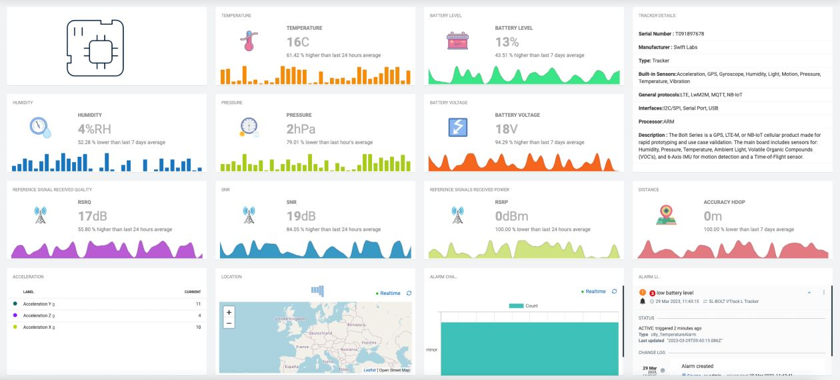

*Figure 1: An IoT platform provides a means to control your various applications and IoT devices, as well as manage the process of collecting, analyzing, and storing the data you generate.*

**IoT platform capabilities**

At a basic level, IoT platforms should allow you to connect and [manage your devices](https://www.cumulocity.com/product/device-management/) with ease, offer application enablement and integration tools, and analyze your IoT data for actionable insights.

**IoT connectivity**

Connection is at the heart of IoT: Devices are connected using protocols to share information and enable new insights. An IoT platform provides out-of-the-box connectivity to many device types and protocols.

For devices that do not support standard IoT protocols, an IoT platform is especially valuable if it offers a software development kit (SDK) to integrate devices with the rest of your ecosystem. Leading IoT platforms enable connectivity and integration using publicly documented APIs.

**IoT device lifecycle management**

An IoT platform allows you to [manage the lifecycle of IoT devices](https://www.cumulocity.com/resource-library/what-is-iot-device-management/) and sensors—from planning and onboarding, monitoring and maintenance, through to retirement—remotely from a centralized location. Robust device lifecycle management processes are often neglected in early-stage IoT projects, when the focus is on building and launching a solution, but they are fundamental to scale a rollout and maintain reliable performance.

Enterprise IoT users need to update and communicate with devices efficiently in a controlled, secured, and phased way. One example of this is the bulk registration of devices. Another is updating software and firmware to maintain performance, uptime, and security. An IoT platform should allow you to access and monitor critical information easily, such as system resource information, alarms and errors, cellular signal strength, or GPS location.

**Scalable IoT data management**

IoT data is the source of insights. An IoT platform handles data logging, storing, and processing, and manages data transactions. IoT data comes from many devices and locations and spans many data types. IoT platforms can orchestrate action based on real-time data and coordinate the long-term storage and analysis of large data sets to power analytics.

**IoT integration**

An IoT platform needs to be much more than a passive destination for data from IoT sensors. IoT needs integration to fill its promise, as integrating IoT data with other systems builds value exponentially by helping you use insights from IoT in your existing systems and processes to make better business decisions.

IoT platforms can offer powerful and intuitive routes to integrate device data with enterprise apps, cloud apps, big data apps, and third-party ecosystems and automate actions, workflows, and processes across your operational technology (OT) and information technology (IT) assets—ideally, without coding.

**IoT application development**

Building and maintaining [IoT applications](https://www.cumulocity.com/product/application-enablement/) involves technical expertise, time, and resources. An IoT platform with application enablement features can help remove the resource technical hurdles to building and deploying applications.

Many businesses see value in enabling their IoT users to develop custom applications with an application builder—or by extending the platform’s default applications to meet their specific business needs and requirements.

From amending existing applications according to customer needs to effectively scaling successful applications, an IoT application enablement platform provides users with self-service, low-code/no-code tools for developing, deploying, operating, and extending custom IoT applications.

**IoT data analytics**

The value of IoT is not in the fleet of devices and sensors an organization is monitoring, but in the accurate and relevant data derived from these IoT devices and sensors. And the value of that data comes from analytics.

[IoT analytics](https://www.cumulocity.com/product/analytics-enablement/), which encompasses historical analytics, real-time analytics and predictive analytics, applies context to IoT data to reveal useful information, so you can make accurate, real-time decisions that deliver value.

An IoT platform with powerful analytic capabilities enables you to access this key data and discover insights. You can create dashboards that pull together data, so you have a single view of the status of all devices and how your project’s performing.

An IoT platform with self-service analytics puts key data into the hands of many. The more widely accessible your insights, the greater their value across the entire enterprise.

**IoT platforms: From edge to cloud**

Many IoT platforms run in the cloud to take advantage of speed, scale, lower costs, and access from around the world. For organizations that run remote assets, it is also important to many customers for an IoT platform to support edge computing.

[IoT edge](https://www.cumulocity.com/resource-library/what-is-edge-computing-in-iot/) computing puts data processing closer to the sensors, rather than sending a full stream of data to the cloud. It is an advantage for organizations that have sensors and devices in places with limited connectivity, produce too much data to send to the cloud cost-effectively, or need millisecond response times from analytics.

IoT edge computing exists on a spectrum. On one end, [thin edge](https://thin-edge.io/) is defined by an architecture where data from devices are collected and transmitted for centralized processing. It is a lightweight and modular approach that provides new or current devices with an easy, rapid way to connect to established systems. Thin edge is often used for applications that rely on low-powered, resource-constrained sensors.

[Thick edge](https://www.cumulocity.com/resource-library/what-is-edge-computing-in-iot/) is on the other end of the spectrum. In a thick edge architecture, processing is more decentralized and occurs closer to data collection. Consider the processing that occurs in an autonomous vehicle. Instead of sending sensor data to be processed on a distant server, which would lead to latencies too high to safely respond to sudden changes on the road, a vehicle’s systems process data directly onboard for autonomous navigation.

To take advantage of IoT edge computing, an IoT platform should enable you to develop solutions once, and deploy them anywhere: on any cloud, at the edge, or on-premises.

**How does an IoT platform work?**

An IoT platform works by supporting the connectivity and communication between all the components in your IoT ecosystem through one application. It connects your devices and sensors—from registering one new device to bulk connecting thousands of devices. It allows you to remotely manage your devices and device groups, for example, by updating device firmware and software.

An IoT platform then facilitates data transmission and applies analytics to the collected data. It allows you to access IoT device data at both a granular and high-level view.

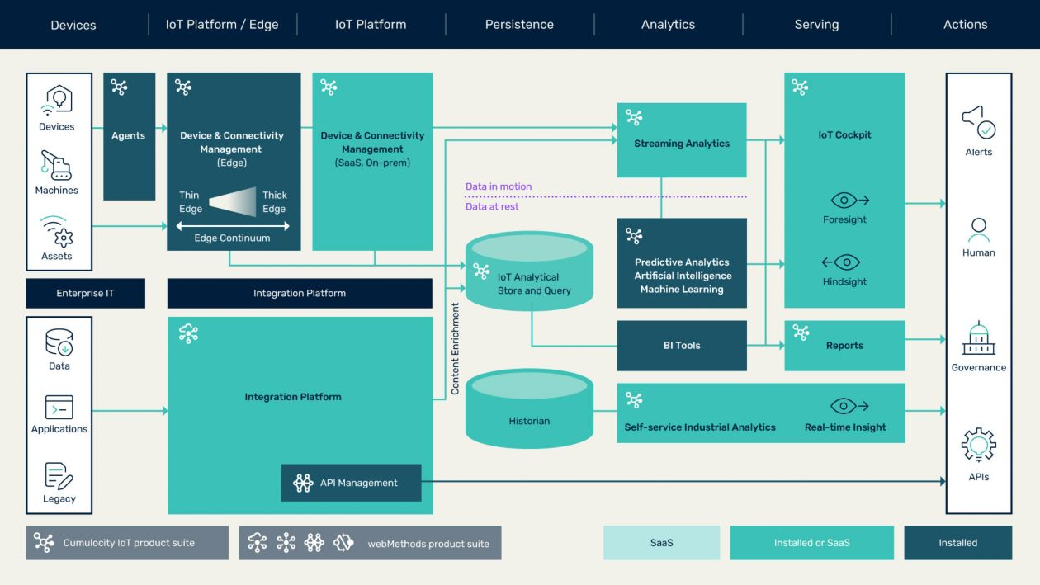

*Figure 2: IoT reference architecture.*

Finally, an IoT platform integrates this device data with other business applications and systems of record, so you can generate insights and make impactful decisions.

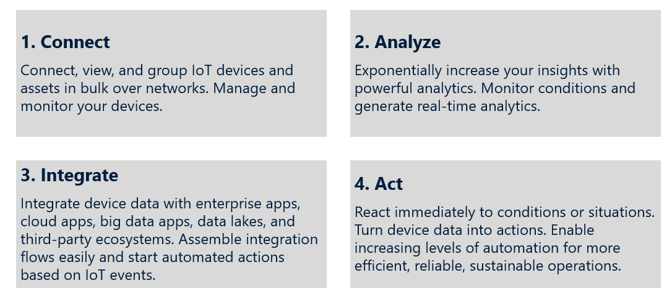

*Figure 3: 4 components of an IoT platform: Connect, Analyze, Integrate, Act.*

**How to choose an IoT platform**

When [choosing an IoT platform](https://www.cumulocity.com/resource-library/internet-of-things-iot-buyers-guide/), ask:

**Technicality**: Does the platform remove technical complexity from IoT projects? Or does it require outsized investments of time and resources to stand up and maintain?

**Scalability**: Does the platform scale effectively when many devices are connected? Can it scale to streamline management of many devices across their life cycle?

**Flexibility**: Does the platform enable you to run on the hardware or cloud provider of your choice? Does it allow you to experiment with new concepts and business models?

**Extensibility**: Does the platform empower you to easily build your own differentiating services?

**Simplicity**: Does the platform enable you to run with a consistent architecture from the edge to cloud and on-premises?

**Universality**: Does the platform enable every stakeholder in your organization—including development teams, equipment operators, and business leads—to build solutions, define rules, create dashboards, and manage other aspects of the platform?

**Security**: Is the platform certified with the highest grade for security?

**Cost and ROI**: Will the platform reduce IoT operational costs, help grow your revenue, and promise substantial ROI?

**Speed**: Will the platform help you create pilot projects efficiently to test and learn how to build new capabilities and services?

**Visibility**: Will analytics be accessible to a wide range of people in your organization?

**Support**: Will you have access to professional services and experts who can help support your IoT journey and empower your team to succeed?

**IoT platform advantages**

An IoT platform simplifies things for you with self-services tools and a configuration-driven approach. It’s designed to give you complete business visibility and control of all the remote assets in your organization on a resilient platform you can trust.

**IoT platform supports new business models**

“As-a-service” business models help you stay closer to customers and gain a competitive advantage by creating new products and differentiating services that can provide resilient, recurring revenue.

However, making the shift to new business models and transitioning to service-based relationships can be a challenge.

An IoT platform provides businesses with data they need to transition with confidence. It helps organizations build bridges with their customers through recurring services for [remote monitoring](https://www.cumulocity.com/use-cases/remote-monitoring/), more [smart field services](https://www.cumulocity.com/use-cases/smart-field-services/), and [performance optimization](https://www.cumulocity.com/use-cases/performance-optimization/), all to improve the customer experience.

The most forward-looking are building [Equipment-as-a-Service (EaaS)](https://www.cumulocity.com/use-cases/equipment-as-a-service/) models that package products and services in an integrated offering.

**IoT platform scalability**

Because IoT-enabled services are becoming an increasingly important part of serving customers, an IoT platform that can help support your scalability is incredibly beneficial. IoT projects often start out small but then grow quickly when the first successes materialize. An IoT platform should be able to start as a proof-of-concept and then use the same platform and interfaces to expand to multiple sites, devices, and data points. And a platform where costs scale efficiently, even as deployments scale exponentially, is even better.

**IoT platform security**

An [IoT security solution](https://www.cumulocity.com/resource-library/industrial-iot-security-what-you-need-to-know/) is an absolute essential to doing business in today’s connected world. Without security, your business is vulnerable to hacks and data security breaches. Private information can become public and exploited, threatening the well-being and reputation of your company, your customers, and business partners.

**IoT platform cost savings**

An IoT platform saves organizations substantial development costs to build IoT-capabilities in-house. And further down the line, an effective IoT platform allows organizations to grow revenue with value-added capabilities to deliver IoT services.

To summarize:

IoT systems consist of four primary components: the hardware, the software, the user interface, and the network.

An IoT platform is what connects the four components into a cohesive, manageable, and interpretable system. These platforms help make data ingestion, communication, device management, and application operations a smooth, unified process.  It makes developing your IoT system faster, easier, and much more practical.

**The 5 types of IoT Platforms**

There are five types of IoT platforms:

1. **IoT Connectivity Management Platforms**

IoT Connectivity Management platforms are, as the name suggests, centred around the networking component of IoT systems. They provide users with the software, connectivity hardware, and data directing necessary for keeping their devices online. Their networks generally rely on existing carrier services and Wi-Fi, configuring the connection in a way that allows for easy IoT setup.

1. **IoT Device Management Platforms**

IoT Device management platforms specialise in the grunt work involved with IoT devices. They ensure that everything is connected and secure, and keep you updated on the status of your devices. Device management platforms update the firmware, notify you of changes in your devices, report metrics, and patch security. This kind of IoT platform will help you with the routine tasks associated with your devices, no matter how many you have.

1. **IoT Cloud Platforms**

IoT Cloud platforms provide users with the infrastructure required to create a cohesive IoT system. They're a central location for all of your backend processes and data to exist and operate. One of the biggest benefits of cloud platforms is their scalability; regardless of how small you start; a cloud platform can grow with you and your IoT system.

1. **IoT Application Enablement Platforms**

IoT Application enablement platforms are a one-size-fits-all approach that offers users everything they need to get an IoT system off the ground. They provide you with the devices, software, development, and deployment of IoT systems. They're a one-stop shop for kickstarting your system, saving you from having to manage developers, network configuration, and hardware engineering yourself.

1. **IoT Advanced Analytics Platforms**

IoT Advanced analytics platforms are a great solution for data-driven IoT systems. Users looking for sophisticated IoT systems that utilise machine learning, artificial intelligence, statistical modeling, and mass data harvesting can use this kind of platform to interpret and act upon the gathered data. IoT systems that primarily work to ingest data, rather than perform tasks, will benefit the most from these platforms.